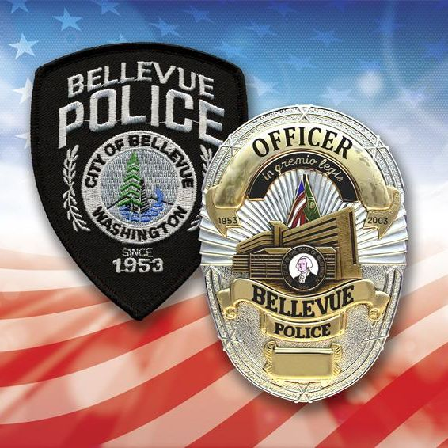
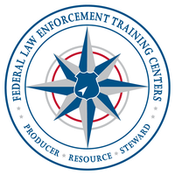
Hosting

Federal Law Enforcement

Training Centers

Basic Tactical Medical Instructor Training Course
The Basic Tactical Medical Instructor Training Program (BTMITP) is a highly intense training program requiring a physical demand on the student and consists of lecture, labs and skill practice. The law enforcement officer will gain knowledge and skills necessary to mitigate the loss of their life or the life of another while in a dynamic environment. The skills will address treating life threatening injuries in an austere environment with limited equipment, lack of medically trained personnel and prolonged time to evacuation.
Applicant must be a law enforcement officer/agent with arrest authority in the prevention, detection, apprehension, detention and/or investigation of felony and/or misdemeanor violations of federal, state, local, tribal, or military criminal laws.
August 16-18, 2021 - 07:30 to 1700
The Bellevue Public Safety Training Center
1838 116th Ave NE
Bellevue, WA 98001
Point of Contact: BPD Cpl. A. Romero – HROMERO@Bellevuewa.gov
FLETC: https://www.fletc.gov/basic-tactical-medical-instructor-training-program
No Cost to Attend for LEOs

Limited to 24 attendees

