Save the Date!
10th Annual Northwest Regional CIT Conference
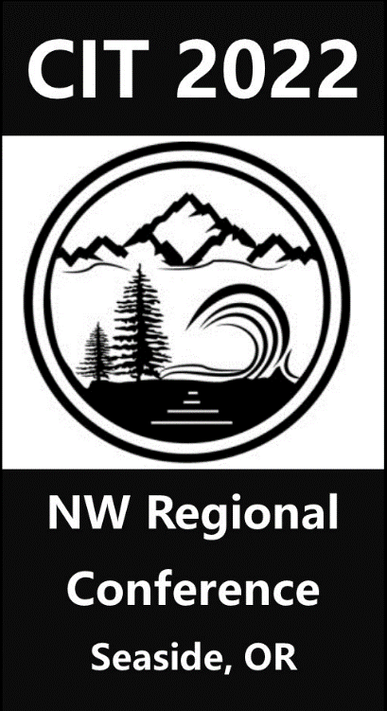
May 23-26, 2022 ≈≈≈ Seaside, Oregon

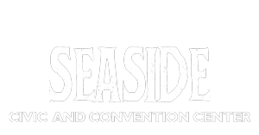
Conference Location

Conference Website
www.cithappens.com

