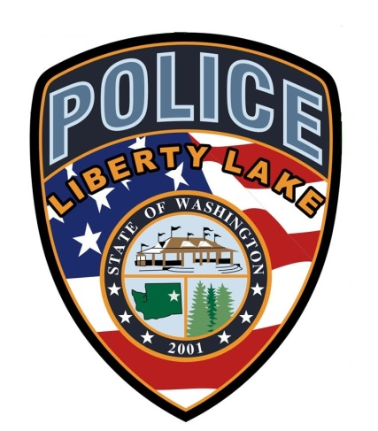

LIBERTY LAKE
POLICE DEPARTMENT

TRAINING ANNOUNCEMENT

Glock Professional
Basic Armorers Course

April 18, 2023

Location
Liberty Lake Police Department
23127 E Mission Ave
Liberty Lake, WA 99019

Cost: $250.00
This is a one day 8 hour course

Certification is good for 3 years

To Register:

https://www.glocktraining.com

Host Agency Contact
Officer Derek Arnold
(509) 755-1140
darnold@libertylakewapd.gov

