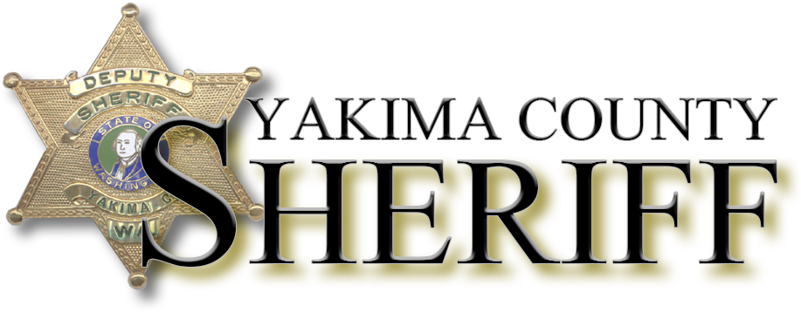
Presents
Death and Homicide Investigation By PATC

Dates: May 24th-28th
Location: West Valley FD Training Room
10000 Zier Road, Yakima, WA 98908
Time: 0800-1700
Equipment: Note Taking Material
Cost: $500
Summary: The Yakima County Sheriff’s Office is hosting a 5 day Death and Homicide investigation class taught by the Public Agency Training Council. A more in-depth description of the course can be found at PATC.com/courses/Homicide-death5.html.

For further information and registration:
Contact: Kyle Cameron
509-490-2595
Kyle.Cameron@CO.Yakima.WA.US

