Leadership- The West Point Model
Hosted by the Snohomish County Sheriff’s Office
and the Lake Stevens Police Department
Sponsored by the Western Regional Counterdrug Training Center

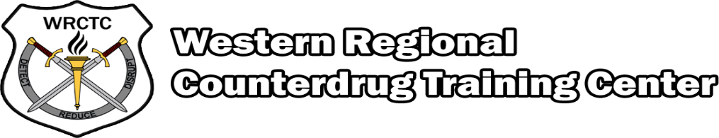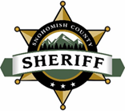
Course info/  Attendance: | See attachment for course information. You must complete all 3 weeks of the training in order to receive a certificate.
Dates: | Week 1: April 12th-April 16th, 2021  Week 2: May 10th-May 14th, 2021  Week 3: June 7th-June 11th, 2021
Location: | Lake Stevens Police Department Training Room  1825 S. Lake Stevens Road  Lake Stevens, WA 98258
Class Hours: | Monday-Friday 0800 to 1700
Travel/Meals  & Lodging: | Responsibility of the applicant or his/her agency
Costs: | The capacity for this highly sought-after course will be 35.  There are a limited number of spaces left.  The cost will be $1,000 per person.
Attire: | Visitors are encouraged to wear their agency logo shirt/uniform or agency ID badge. Please have your police ID available if you will be attending the course armed.
Note-Taking: | Note-taking items such as notebook paper, pens, and pencils, will not be made available at the training site, and are the responsibility of each attendee.
Access to facility: | Please arrive for class on time. Parking in the area may be limited.
Telephone: | If you have questions, please contact Lt. Mike Martin at 425-754-1272.
Attendance: | Instructors must pre-approve any-time out of class.
Registration: | Please email Lt. Mike Martin to register for this course at m.martin@snoco.org. The Snohomish County Sheriff’s Office will be processing all registration and payments for this course. Once you register, additional information will be sent to you regarding where payments need to be sent.
Cancellation Deadline: | March 26th, 2021  Notify Lt. Mike Martin via e-mail m.martin@snoco.org. Your agency will be billed $50 or the course fee whichever is greater, for late cancellations and no shows. No exceptions will be made.
Responsibility for injuries: | Although instructors will at all times maintain a high degree of care for the safety of all persons attending the school, it must, be understood that neither the Snohomish County Sheriff’s Office, nor any of the cooperating agencies can or will assume financial responsibility for injuries or illness suffered as a result of any training received, nor can or will be responsible for any loss to students as a result of damage to their property through fire, theft or other causes. Each attendee must understand that this training is at the attendee’s own risk.
COVID-Safety Precautions | In an effort to keep you, your family, your fellow classmates, and our community members healthy, we are implementing a Voluntary COVID-19 Health Screening.  We ask that prior to responding to the training, you take your temperature and ask yourself the following YES or NO questions.  “YES or NO, before coming to training, have you had any of the following:”  • A new fever (100.4 degrees F or higher), or feel feverish?  • A new cough that you cannot attribute to another health condition?  • A loss of taste or smell?  • New shortness of breath that you cannot attribute to another health condition?  • A new sore throat that you cannot attribute to another health condition?  • New muscle aches (myalgias) that you cannot attribute to another health condition or exercise (pulled muscle)?  If you answer YES to any of the screening questions, DO NOT attend training. Contact Lt. Mike Martin at 425-754-1272. Follow any COVID-19 protocol or guidelines set by your respective agency.
COVID-Safety Precautions continued. | We will have a thermometer on site each day, and extra PPE. This will include hand sanitizer and masks.

