wsp crime lab 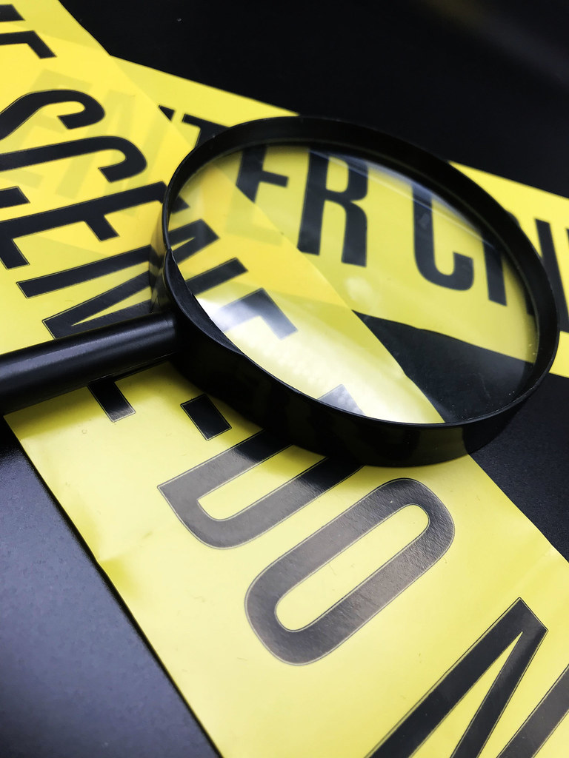training  This Photo by Unknown Author is licensed under CC BY  August 15th, 2024 Thursday  1pm – 5pm  Location:  Richland Police Department  871 George Washington Way | FREE CLASS  Forensic Services Overview  Types of analysis  Evidence Collection and Submission  How to submit  Class Description-  WSP Crime lab forensic experts will share valuable information about forensic evidence collection and the types of analysis they conduct. This class is designed for detectives, patrol officers and property and evidence specialists.  To register:  Contact- Jory Parish  509-942-7338  jparish@ci.richland.wa.us

