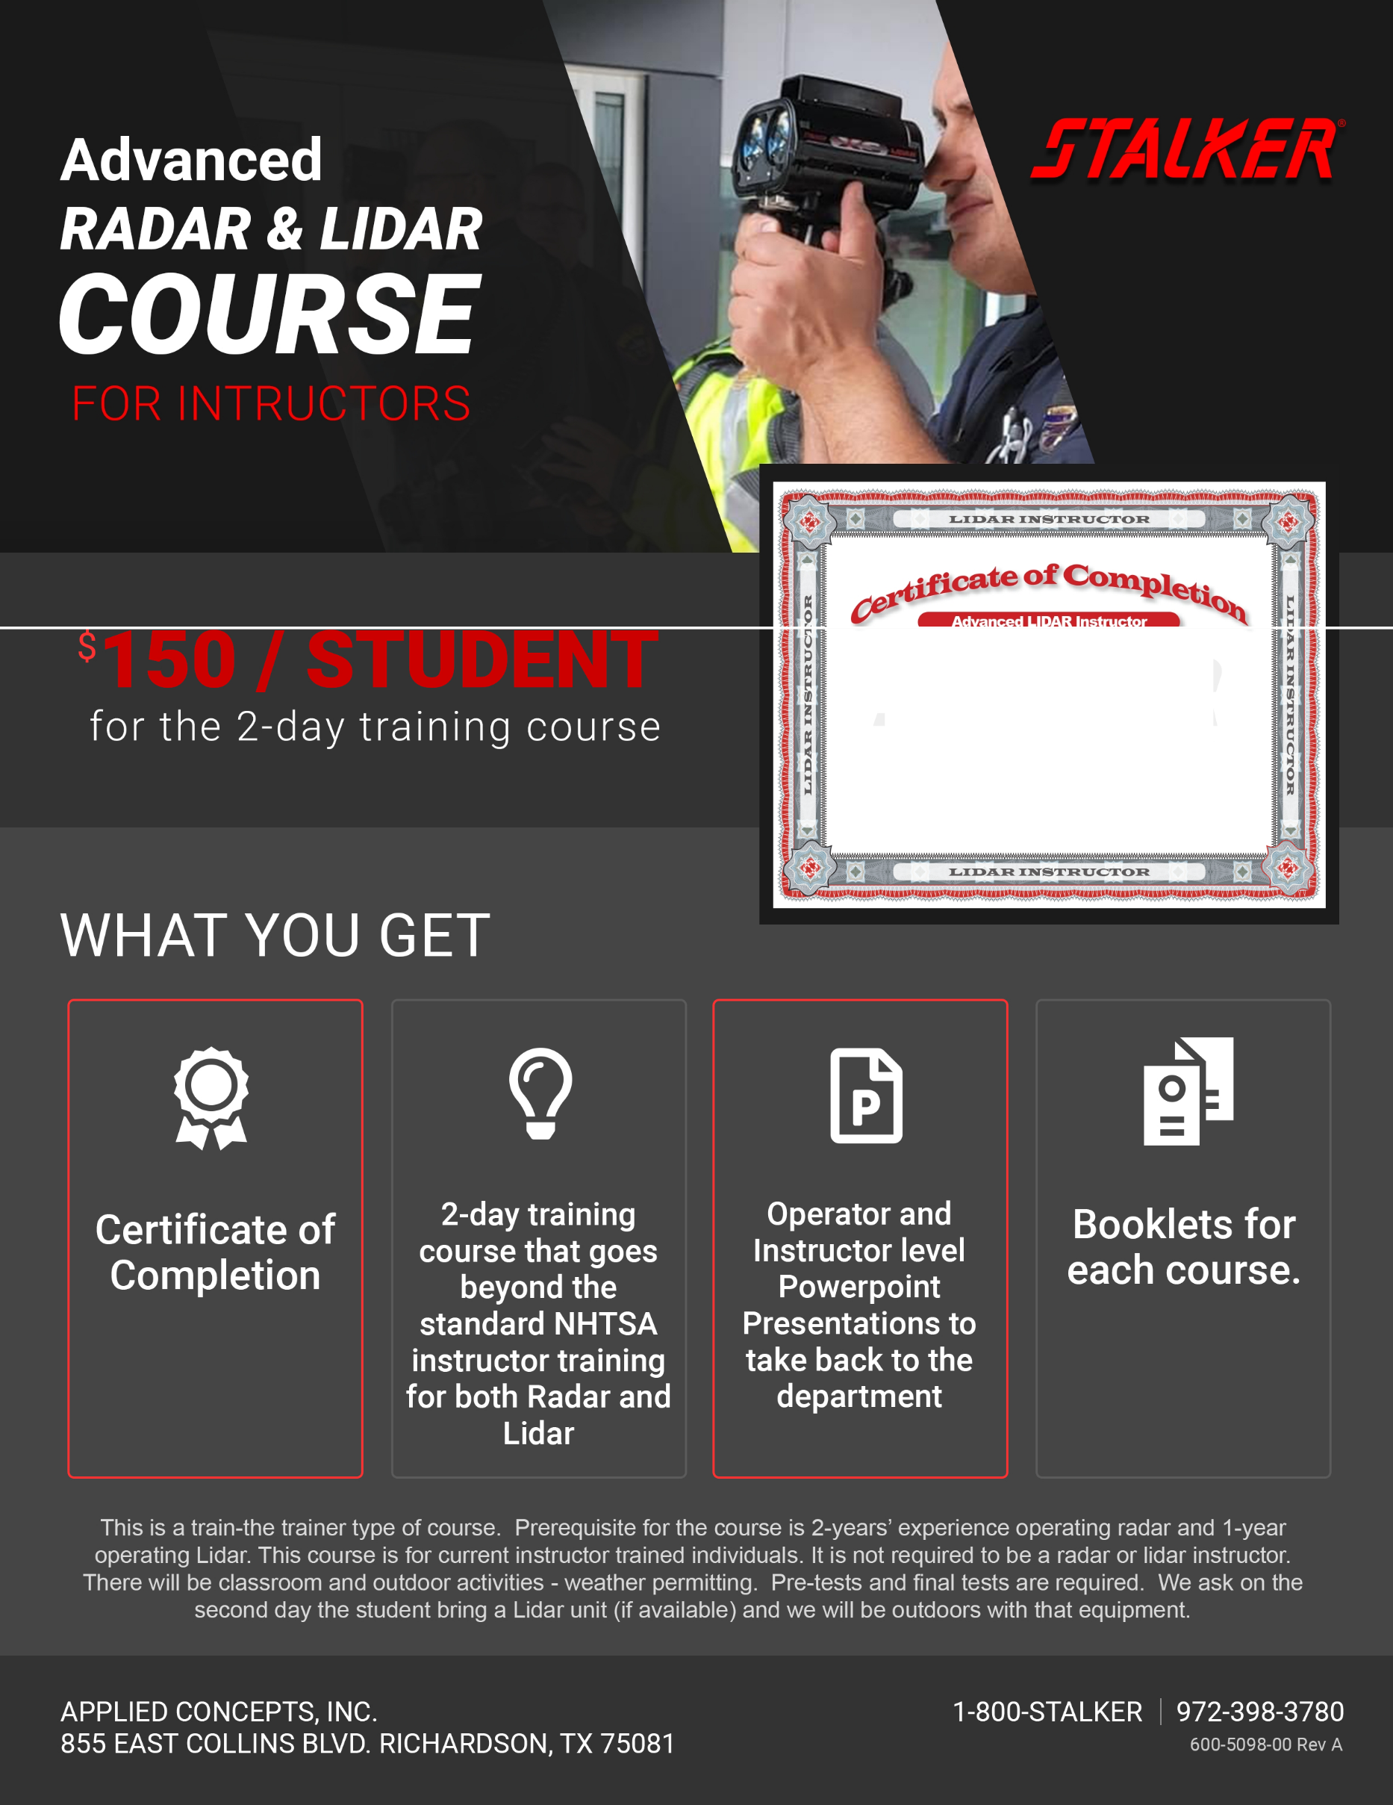

FREE COURSE!

SPACE IS LIMITED!

WHEN: MARCH 26-27, 2024
8:00 AM – 5:00 PM

WHERE: DUPONT POLICE DEPARTMENT
1780 CIVIC DRIVE
DUPONT, WA 98327

To register email:
Dan.Saboe@dupontwa.gov

ssP

Advanced LIDAR Instructor

Officer John Smith Metro Police Dept.
Department

Hassuc cessfu ly compleled a course of inst ruclioninlheo peralion ofpoli ce trafficll DAR andisd eemedqua lified to operate, instructolhersa ndtea ch othe rsas instructor.;in theoperaliooof
trafficLIDARdevOOOStodeterminelhespeedofmovr>gvehicles

