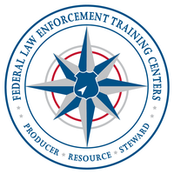
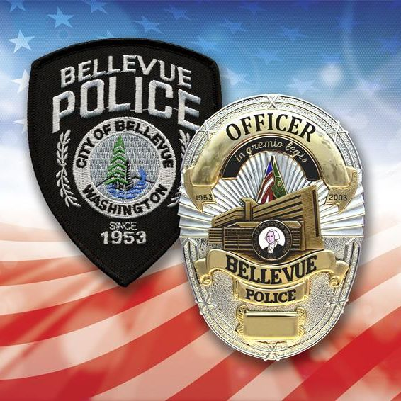
Hosting

Federal Law Enforcement

Training Centers

Tactical Medical for First Responders Course
The Tactical Medical for First Responders program is designed to define a Medical Threat Assessment, to include a medical plan for a tactical operation. Students will learn how to apply techniques to control life threatening bleeding during Care under Fire in a (HOT ZONE). Additionally, they will perform techniques to treat life threatening and non-life threatening injuries during Tactical Field Care in a (WARM ZONE). During the program students will demonstrate lifting, moving and extricating victims from a tactical or hostile environment during Tactical Evacuation Care.
August 20, 2021 - 07:30 to 1700
The Bellevue Public Safety Training Center
1838 116th Ave NE
Bellevue, WA 98001
Point of Contact: BPD Cpl. A. Romero – HROMERO@Bellevuewa.gov
FLETC: https://www.fletc.gov/tactical-medical-first-responders

No Cost to Attend for LEOs

Limited to 24 attendees

