BRIER POLICE DEPARTMENT
INTEGRITY. HONOR. PRIDE.
IMMEDIATELY HIRING LATERAL AND ENTRY LEVEL POLICE OFFICER
$10,000 INCENTIVE BONUS

Annual salary $66,768 - $89,068

Opportunity to start at top-step depending on experience

Premium pay for education and certain specialties

Health, dental, and vision plan for you and your family
Pay rates are for current contract which expires this year

Expedited hiring process and opportunity for expedited FTO

No written or physical ﬁtness testing required

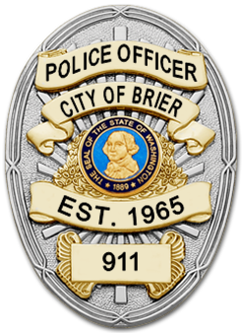
The City of Brier is a wonderful community just 15 minutes North of Downtown Seattle, located in Snohomish County. Brier contains 27 miles of roads and has approximately 7,000 residents. This beautiful community consists of modern single-family homes, vast open spaces, scenic parks and wildlife. The Brier Police Department strives to deliver the highest level of professionalism and service to its citizens while offering 24/7 coverage and collaborative. mutual aid with neighboring agencies. The City of Brier is committed to providing its Ofﬁcers with the resources, technology and support needed to ensure excellent policing and offers opportunities for additional training and self-advancement. Come to a place where you are valued. Come to the Brier Police Department.

APPLICANTS MUST MEET THE WA STATE CRIMINAL TRAINING COMMISSION PEACE OFFICER AND CITY OF BRIER REQUIREMENTS.
Lateral application must be fully completed and include a cover letter and resume.
To apply: download application at: http://ci.brier.wa.us/cityhall/hr.htm

