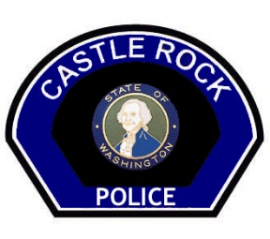
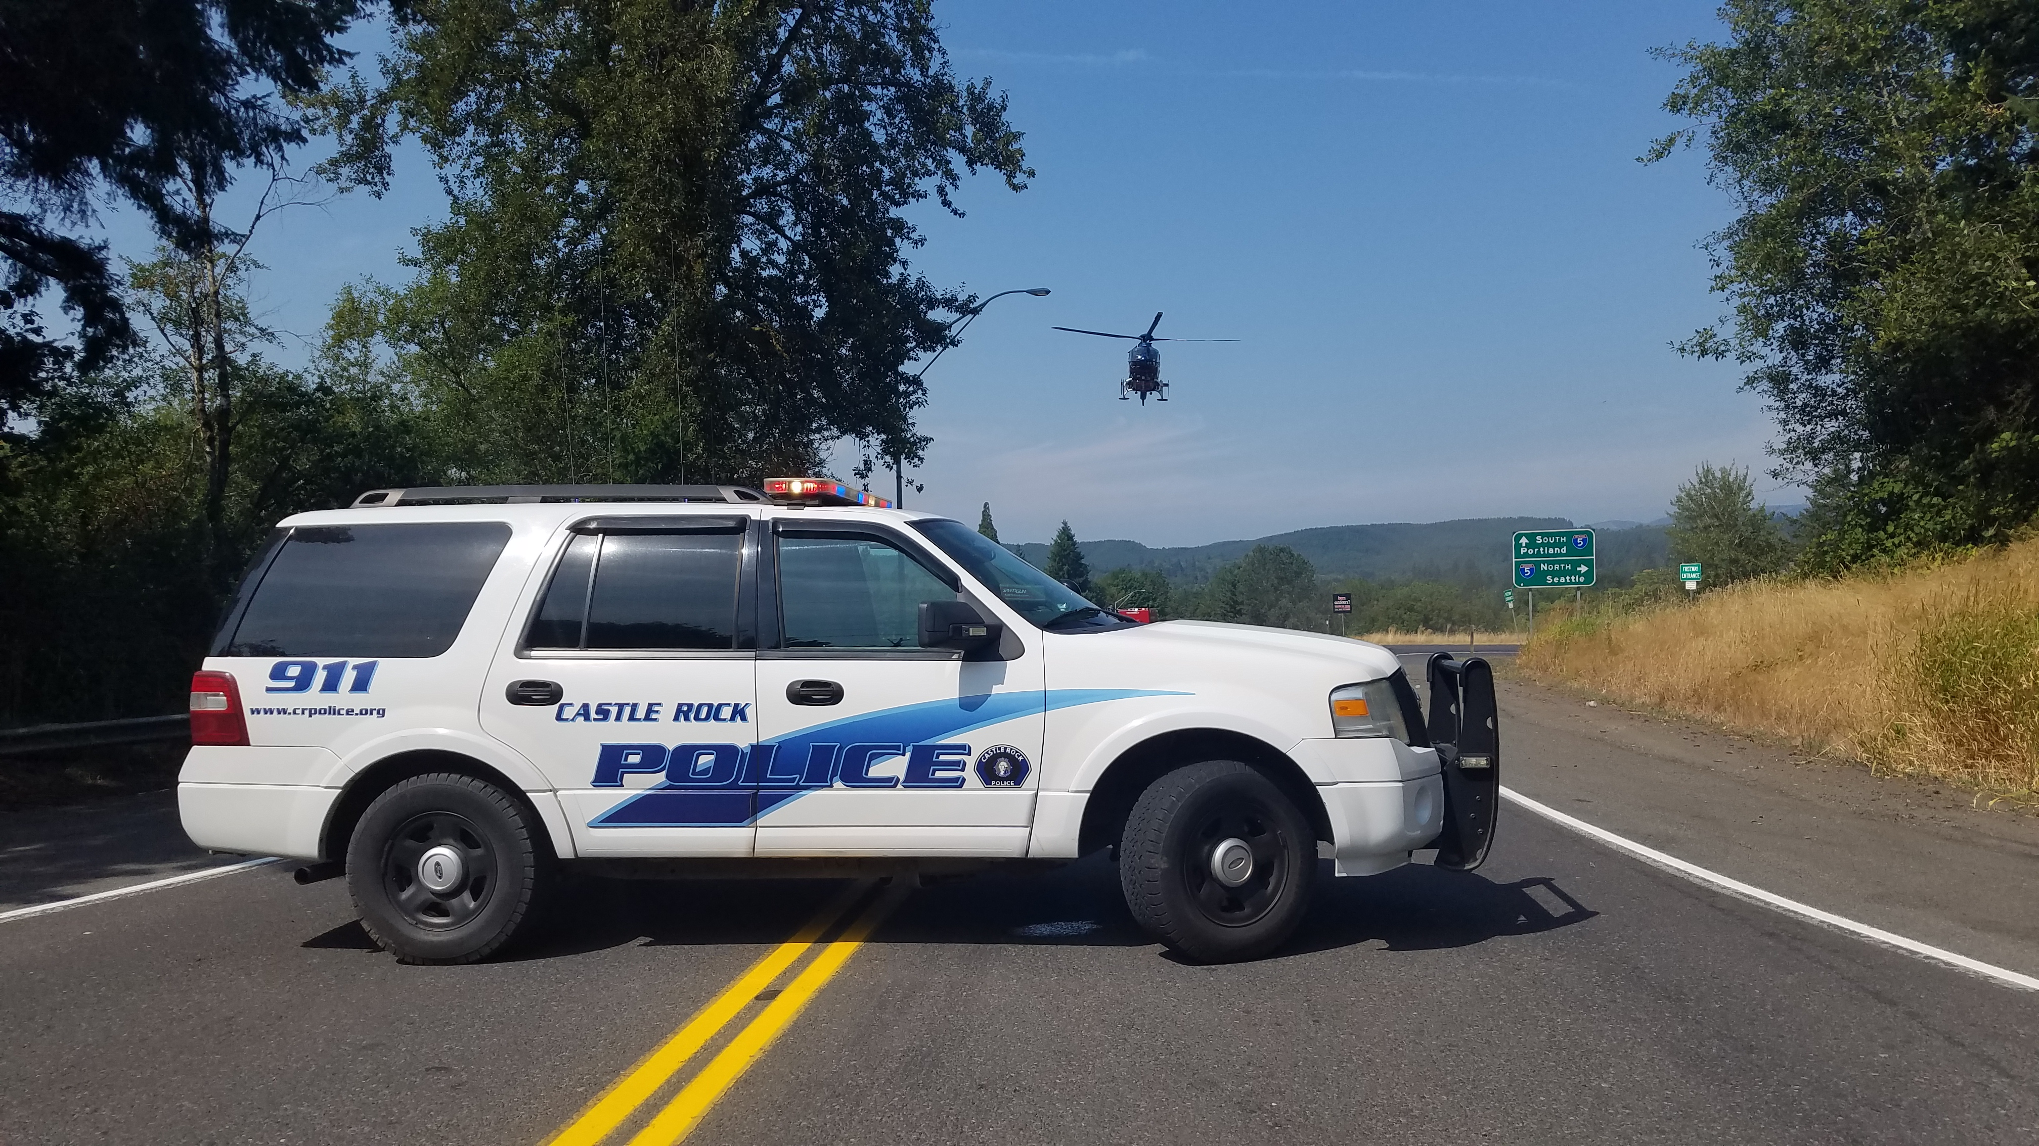
The Castle Rock Police Department is
accepting applications for the position of police chief.

APPLICATION PERIOD CLOSES MAY 15, 2021 AT 5:00 PM

THIS APPLICATION PROCESS IS BEING USED TO ESTABLISH AN ELIGIBILITY LIST FOR A
VACANT POSTION TO BE HIRED WITHIN 2 MONTHS

The Agency: The Castle Rock Police Department consists of 5 commissioned officers, 10 reserve officers, and one support staff. Castle Rock is a vibrant community of over 2,000 people located on the Interstate 5 corridor, approximately 30 miles north of Vancouver WA, the Gateway to Mt. St. Helens. The Police Department enjoys strong community support. The department was awarded the Exemplary Collaboration Award from the Washington State Department of Social & Health Services.

Benefits: Salary - $90k-$105k depending on experience/qualifications.

Time Off: Full time employee base benefits plan applies, but position is open to negotiated employment contract.

Medical/Dental/Vision: The City of Castle Rock provides medical, dental and vision coverage for the employee, spouse and legal dependents with no employee cost per month.

Retirement: Commissioned Officers for the Castle Rock Police Department work under the LEOFF 2 Retirement System. Supplemental retirement is also offered through the Teamsters Pension Fund as well as a Deferred Compensation program.

Qualifications: To be considered the applicant must meet the base civil service requirements as stated in the Castle Rock Civil Service Commission rules and are as follows:
RULE 2 – GENERAL QUALIFICATIONS OF ALL APPLICANTS
Section 1: All applicants applying for positions of any kind for said Civil Service:
1. Must be a citizen of the United States of America.
2. Shall be able to read and write the English language.
3. Must be at least 21 years old.
4. Must be in ordinary good health.
5. Shall possess a good moral character and of temperate and industrious habits as determined by a thorough background investigation.
6. No town, city or municipality shall require any person applying for position or employment to discriminate in any manner against any such person because of his/her residence outside of the limits of the city.

RULE 5 - EXAMINATIONS AND CERTIFICATION

Section 1: POLICE CHIEF
Applicants must meet the education, experience and certification standards as described in RULE 2 – SECTION 1 GENERAL QUALIFICATIONS as set forth in the Castle Rock Civil Service Rules and Regulations.
Qualifications for this position include but not limited to the following:
- Must be in ordinary good health.
- Must have graduated high school or possess certificate of equivalency.
- Minimum of 10 years as a sworn law enforcement officer.
- Possess a certification from an accredited law enforcement training facility (i.e. Washington CJTC or other state equivalent).
- Possess a minimum of 45 college credits and having obtained a degree or certificate of completion from an accredited college or training program.
- Must have a minimum of 5 years supervisory experience in law enforcement and having achieved a rank of sergeant or higher.

Out of state applicants who are accepted and hired will be required to perform and pass an equivalency program through Washington State CJTC within 6 months of hire.
A qualified officer who meets the years of service and supervisory requirements listed above may petition for a waiver of the college credit requirement from the Castel Rock Civil Service Commission. All waiver petitions shall be submitted in writing at time of application.
Must submit a resume, cover letter, and comprehensive application packet.
Applicants will be screened based on the combination of listed eligibility requirements. Testing may include, but is not limited to: Written Examination or Assessment Center and Oral Board interview. The application and testing process may be waived at the discretion of the Castle Rock Civil Service Commission. If this becomes the case, the Oral Board score would be based on a full 100% ratio. Any person who fails to attain an average of a t least seventy-percent (70%) of complete proficiency on an examination shall be deemed ineligible. (See also Rule 2 - QUALIFICATIONS) (See also Rule 7 - PROMOTIONS)
To Apply: Contact Civil Service Secretary Justin Stennick at jstennick@crpolice.org or at (360) 274-4711 to request information. Resume, cover letter, and application packet needs to be submitted before the application period ends May 15, 2021 at 5pm. Application packet can be obtained at https://ci.castle-rock.wa.us/jobs.htm .All application packets can be delivered in person or mailed to PO Box 475 Castle Rock, WA 98611

