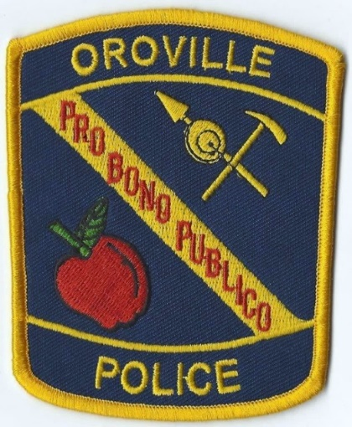
Join a community that
supports its officers!

Oroville, Washington
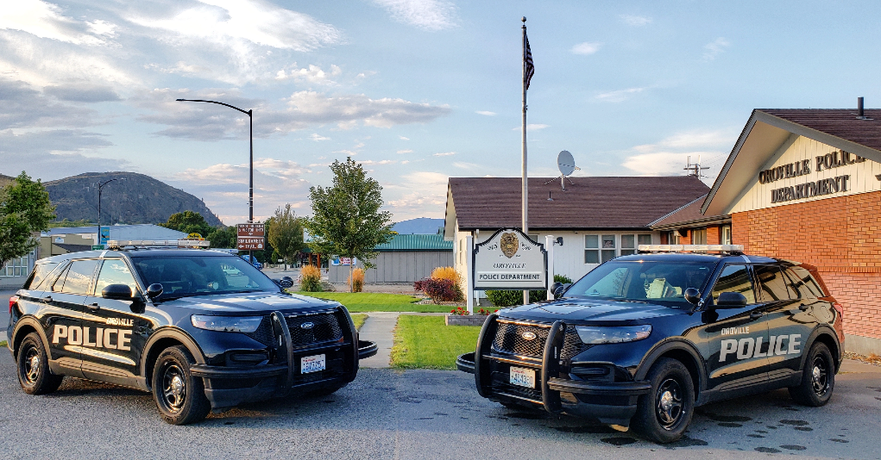
Sergeant ▪ Lateral ▪ New
Lake Osoyoos

The Oroville Police Department seeks lateral applicants to fill an open officer position. Up to $12,500.00 sign-on/retention bonus

The current (2024) base lateral wage scale is $5,269.24-$6,361.22 per month, with an expected wage increase for 2025.

We offer assigned take-home vehicles, medical/dental/vision/sick leave/vacation/11 paid holidays/longevity pay/education incentive/second language incentive/low call volume

The mission of the Oroville Police Department is to safeguard the community
we serve, keep the peace, and protect the rights of all citizens.

Our vision is to set the standard for small city Police Departments in Washington State.

INTEGRITY ▪ PROFESSIONALISIM ▪ TEAMWORK ▪ HUMILITY

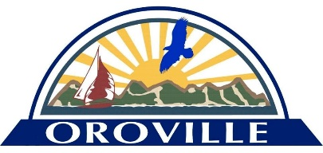
Contact Emily Finsen PH: (509) 476-2926 Email: emily.oroville@ncidata.com

