Lateral/Entry Level Police Officer - City of Westport (Job #23-0001)
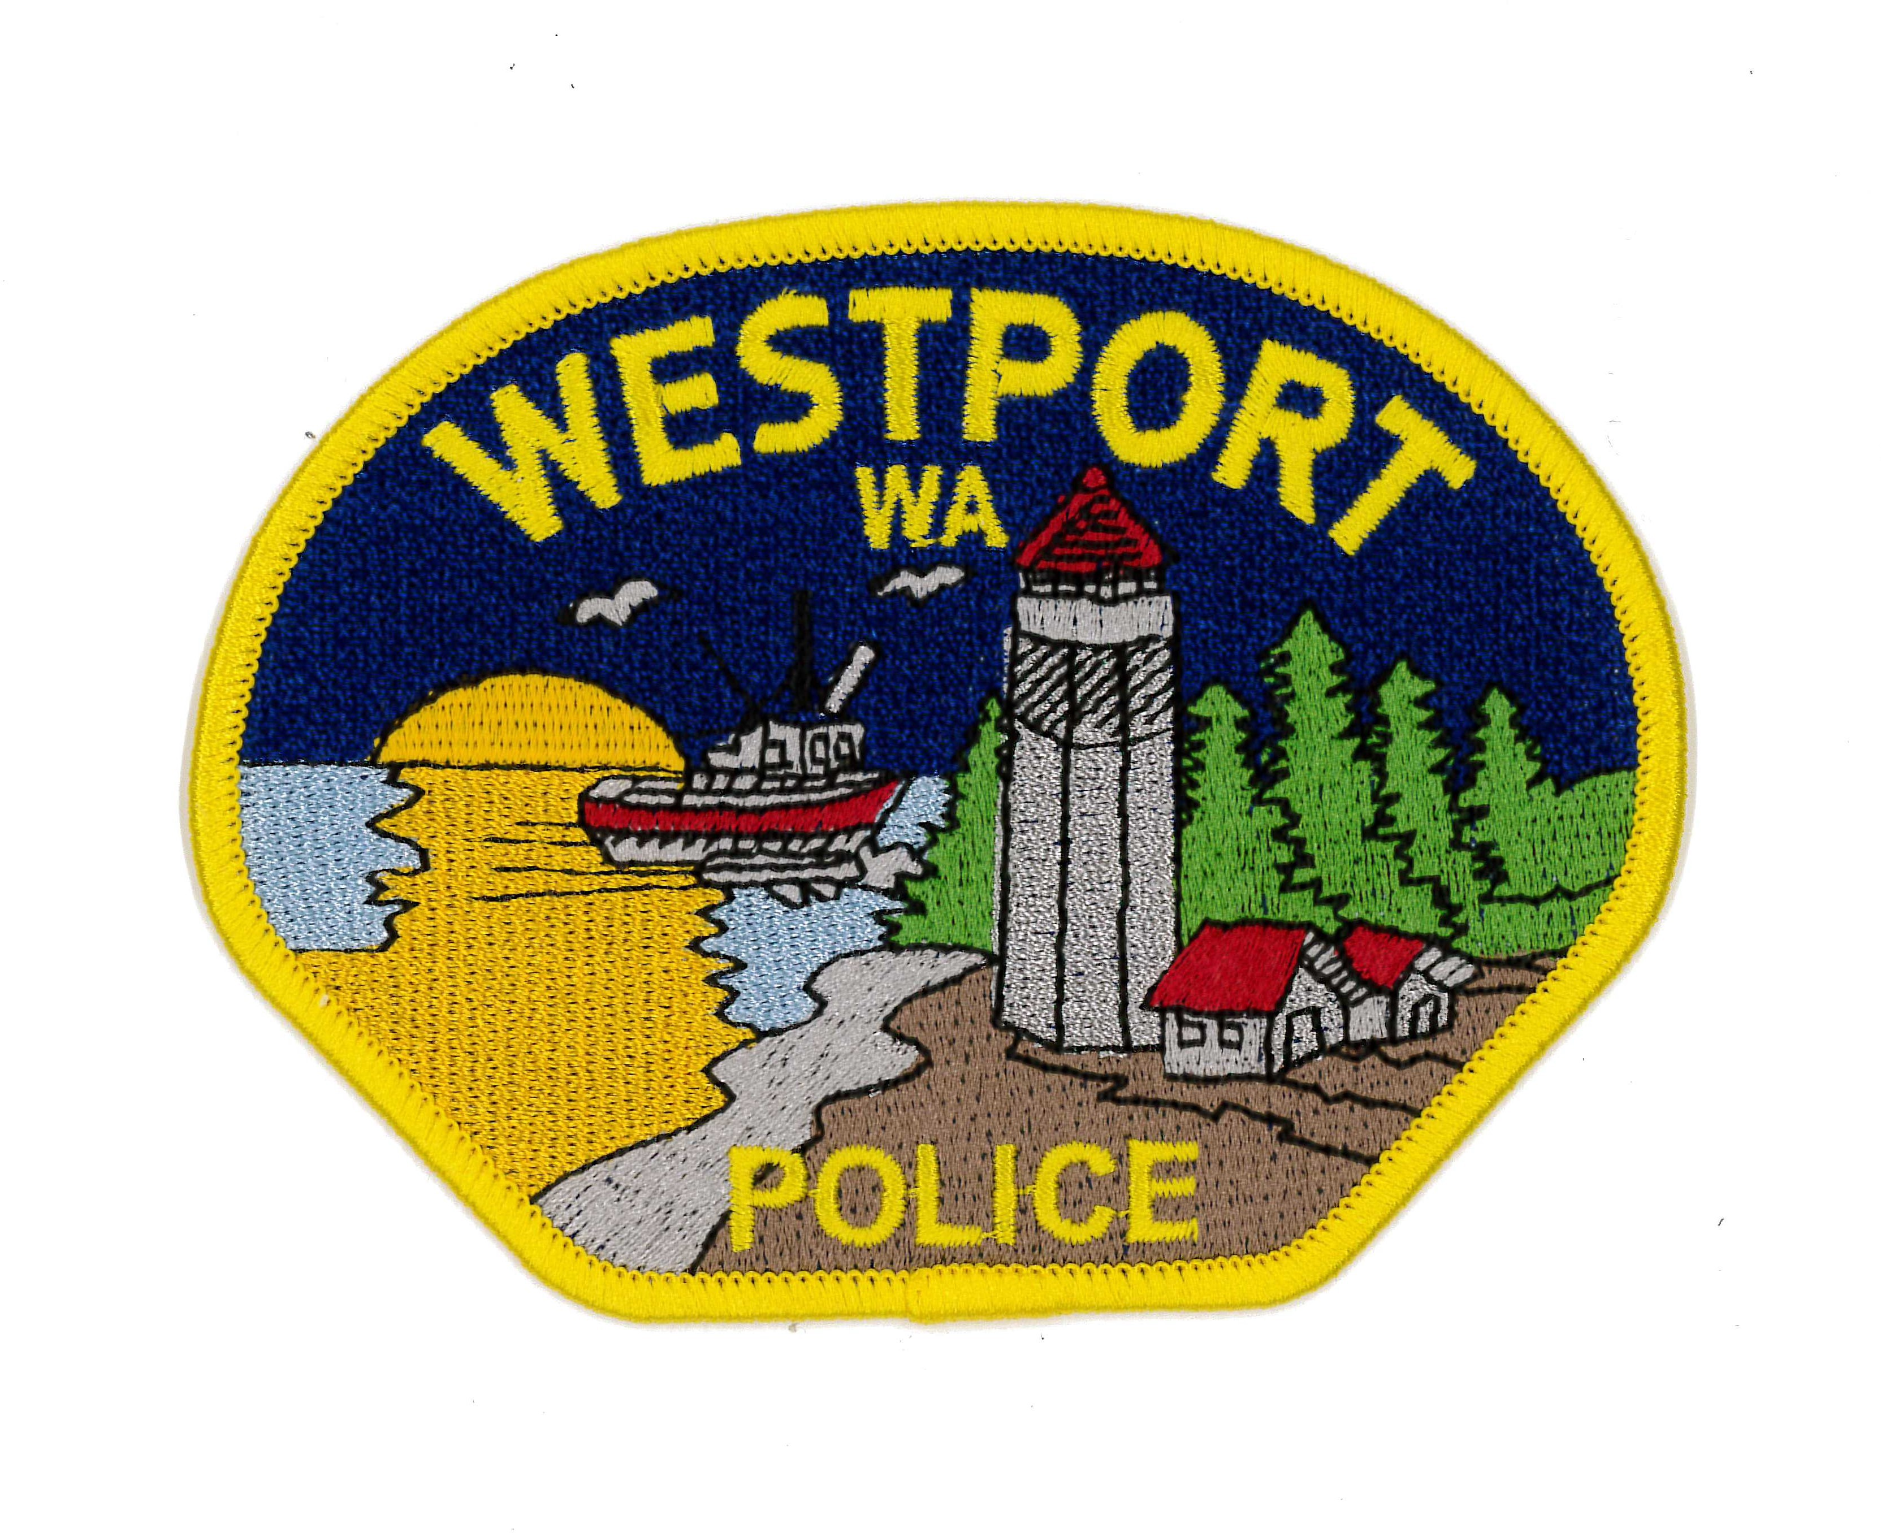
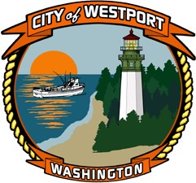

Minimum Salary: $ 71,532 per year Maximum Salary: $ 74,388 per year

Employment type: Full time Department: Police Department

Open Until Filled

Summary - The City of Westport is testing for either a Lateral/Exceptional Lateral or Entry Level Police Officer position. Those applicants who are successful in the testing process will be placed on an eligibility list for potential full- time employment.
Lateral/Exceptional Lateral - This position is a full-time non-exempt position with a total compensation range of $34.39 to $35.76 per hour plus excellent benefits. To qualify, candidates must meet the following requirements: must be a US. citizen; must have a minimum of two (2) years of experience as a police officer and have worked as such at least 24 months within the last 36 months serving in a City, County, or State police agency in Washington, and must have graduated from a State sanctioned police academy. A driver's abstract of records and WA driver's license are required prior to appointment. To apply, candidates must submit a completed City of Westport application, personal history statement and waiver to permit background packet in person to City Hall, or electronically through ci.westport.wa.us.

Entry Level - The City of Westport conducts entry-level testing through Public Safety Testing. Please visit the Public Safety Testing website (www.publicsafetytesting.com) for more information, upcoming test dates, or to apply. To be eligible for this round of hiring you must complete your written and PFAT (Physical Fitness Abilities Test) by end of day July 16th, 2023 with Oral boards dates and times, for qualified candidates, to be determined.

Location:
Westport Police Department 740 N Montesano Street Westport, WA 98595

The City of Westport is an Equal Employment Opportunity (EEO) employer and does not discriminate in any employer/employee relations based on race, color, religion, sex, sexual orientation, national origin, age, marital status, disability, genetic information, veteran's status or any other basis protected by applicable discrimination laws.

Note: In accordance with the Immigration Reform and Control Act of 1986, employment of persons hired by the City will be contingent upon presentation of acceptable documents verifying identity and authorization of employment in the United States.

Questions and/or technical issues regarding the on-line application process should be directed to the City of Westport Human Resources Department at 360-268-0131.

