ARE YOU READY TO ACCELERATE YOUR CAREER?
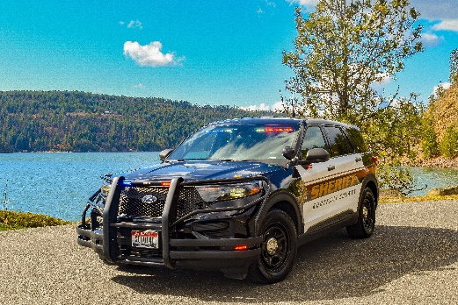
HIRING & RELOCATION BONUSES OF UP TO $7500.00 NOW OFFERED TO LATERALS
The written and physical agility tests will be held the morning of
Tuesday, March 21st, 2023.

The oral board interview will be held the afternoon of Tuesday, March 21st, 2023 for all those who successfully complete the written and physical agility tests. Please come prepared to participate in an interview.
We are currently hiring for both Deputy Sheriff, Patrol and Deputy Sheriff, Jail. Both entry level and lateral applicants are welcome encourage to apply.
- Pay starts at $26.50 (Jail) or $27.70 per hour (Patrol) up to $35.22 per hour for laterals depending on position and law enforcement experience*
- Deputies receive extensive paid training.
- Public Employees Retirement System of Idaho (PERSI), a pension plan with five year vesting, 12.28% employer contribution, and a lifetime payout upon retirement.
- Excellent and comprehensive benefits package. For example, employee-only medical/dental/vision premium of only $55.33 per month. Comprehensive benefits package.
- Do you have student loan debt? This position is Public Service Loan Forgiveness Program eligible allowing employees who qualify 100% student loan forgiveness.
*all wages include $0.50 shift differential. (Lateral candidates only - please call the number below for lateral rate of pay quote.)
WHY SHOULD YOU APPLY?
- Rewarding and meaningful work, providing a necessary service to your community
- No need to travel for academy training. POST Basic Patrol Academy offered locally.
- Ongoing paid educational and training opportunities
- Advancement opportunities
- Special teams opportunities: SWAT, K9, Dive Team, Range, Traffic Investigation Team, Back Country Patrol and more
- Take home cars upon the successful completion of the Field Training Program
- Kootenai County Sworn Officer Matrix
- On-The-Job Training and Apprenticeship Certified Employer (Download PDF reader) for qualified military veterans
DO YOU QUALIFY FOR ENTRY LEVEL?
- Do you have at least a High School Diploma or GED? No college degree required.
- Do you have at least 24 months of work experience?
- Do you possess or have the ability to possess a driver's license and be insurable?
- Are you at least 21 years old?
DO YOU QUALIFY FOR LATERAL?
- Meet all of the minimum requirements as an entry level applicant above
- Have a minimum of twenty-four (24) months experience as a Patrol Deputy/Officer
- Have successfully completed a Basic POST Academy and are a certified Peace Officer

Please view the automatic disqualifiers for working with the Sheriff's Office before applying.
View the full job description
IMPORTANT TIPS FOR APPLYING: We are looking for individuals with the character to be completely truthful in their application materials. During every stage of the process please list accurate information in your responses. Information which is omitted or minimized can disqualify you before we have the opportunity to meet you. If you have any questions regarding this job opportunity please do not hesitate to call, we look forward to speaking with you.

Connect with the Sheriff's Office recruiting team at KCSOrecruit@kcgov.us any time before or after your initial testing. We are here to answer your questions.

LATERAL BONUSES:
Upon hire, a $5000.00 payment is made in the first regularly scheduled paycheck. An additional $2500.00 relocation bonus is offered for lateral candidates who qualify. All payments would be in gross wages and subject to applicable withholdings.
CONTACT US:
KCSO Recruiting Team
kcsorecruit@kcgov.us
Marcia Heglie, Personnel Administrator
mheglie@kcgov.us or (208) 446-1306
Bridget Gernns
bgernns@kcgov.us or (208)446-1304
OUR LOCATION:
Located in beautiful northern Idaho, and home to approximately 171,000 residents, Kootenai County is surrounded by scenic mountains and more than twenty pristine lakes--an outdoor enthusiast's dream. The largest city and county seat is located in Coeur d'Alene and is on the majestic shores of Lake Coeur d'Alene. Learn more about living in Kootenai County.
TO APPLY: Apply online at www.kcgov.us. Must successfully pass the County's pre-employment and subsequent random drug tests. Must also pass a stringent Sheriff's Office background and selection process to include: Oral Board, Polygraph Examination, Psychological Evaluation and Medical Examination.
EOE/Vets Preference/Drug Free Workplace

