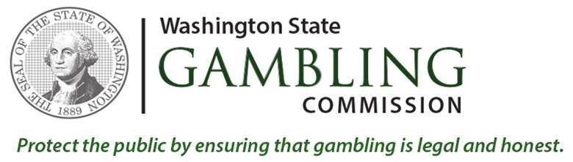  
  
The Washington State Gambling Commission (WSGC) is seeking qualified candidates to fill a full time Special Agent position within our Licensing, Regulation and Enforcement Division. Special Agents are limited jurisdiction law enforcement officers and are exempt from state civil service rules.  
  
Special Agents of the Regulatory Unit are responsible for conducting regulatory and criminal investigations under RCW Chapter 9.46 and WAC Chapter 230 throughout Washington in coordination with federal, state, and local law enforcement and regulatory agencies. The position will be assigned to our Spokane field office. The Agent for this positions will be required to reside within 35 miles of Spokane, Washington.

***New Process for Gambling Special Agent vacancies***:

All Gambling Commission Special Agent vacancies will now be advertised through Public Safety Testing (PST) and careers.wa.gov.

External candidates and internal non-agent employees will need to complete the written exam and Physical Agility Test (PAT) through Public Safety Testing ([www.publicsafetytesting.com](http://www.publicsafetytesting.com)) before submitting an application through careers.wa.gov.

Special Agents interested in applying for Special Agent vacancies ***do not*** need to apply through PST. They will apply directly through careers.wa.gov. Please click [here](https://www.governmentjobs.com/careers/washington/jobs/2640263/special-agent?department%5b0%5d=Gambling%20Commission&sort=PostingDate%7CDescending&pagetype=jobOpportunitiesJobs) to apply.

If you have any questions regarding this opportunity please don’t hesitate to contact me.