ATTENTION!
Law Enforcement Defensive Tactics / Military Combatives Instructors
The Walla Walla Police Dept presents
GRACIE SURVIVAL TACTICS®
Military/Law Enforcement Level 1 Instructor Certification Course
TBD in the 4th quarter of 2020 in Walla Walla aWashington

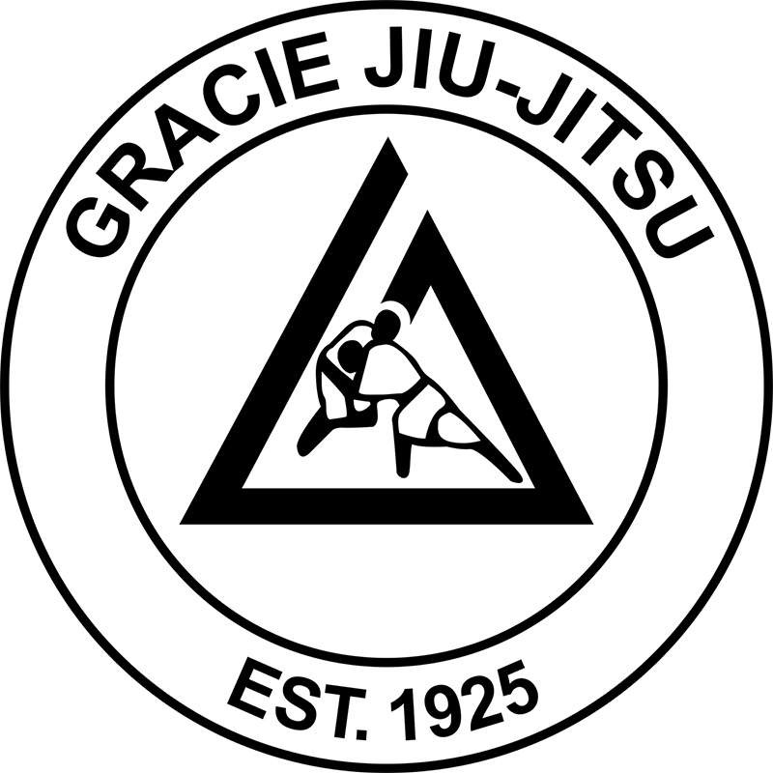

While you are reading this, the bad guy you will soon encounter is training. Are you ready?
Gracie Survival Tactics (GST) is a highly-specialized industry leading Combatives/Defensive Tactics program for Military and Law Enforcement professionals. The 23 techniques featured in the GST course have been adopted by hundreds of Federal, State and Local Law Enforcement Agencies, as well as the Special Operations Community, because they are easy to apply and have been proven to work for all officers regardless of age, weight or athletic ability. GST is designed to reduce liability from excessive force allegations and is applicable to CQB/Room Clearing/High Risk Entry scenarios.
THE GST PROGRAM IS A LIVING CURRICULUM THAT IS CONSTANTLY EVOLVING AND BASED ON THREE RULES:

Rule 1: The suspect always has the ambush advantage.
Anytime you are within document transfer range, you are also within ambush range. In the GST course we teach simple, high-percentage sudden assault defense strategies so that you can neutralize the threat and achieve a position of advantage in the least amount time possible.

Rule 2: The officer should never grapple with the bad guy by choice.
If you are ambushed by the bad guy and taken to the ground against your will, the primary concern is the immediate access the bad guy has to your weapons. In the GST course, we teach a series of leverage-based weapon retention strategies, as well as the core distance recovery strategies so that you can disengage from the fight and utilize the appropriate force options.

Rule 3: In a street fight, there is no “tap out”.
The concept of tapping out was designed for safe sportive practice, but street fights are neither safe nor sportive. In the GST course we teach a total of 23 techniques and every one of them ends with you safely removed from the fight or with the suspect in handcuffs.

FREE ONLINE TRAINING
GST is a 5-day Hands-On Instructor Certification Course where graduates also receive free access to the entire course Online on Gracie University for future refresher training (a $395.00 value).

23 TECHNIQUES THAT COULD SAVE YOUR LIFE-
YOU WILL LEARN TO:
1) Neutralize the initial threat
2) Retain Control of your weapons
3) Achieve a position of advantage

- US Customs and Border Protection Advanced Training Center- Defensive Tactics Instructor SBPA Chuck Smith
“The instant an assault is initiated; the GST techniques bring the fight to a place where the officer can collect his wits and turn the tide. The secret weapon of GST is not the slick submissions that one sees during high level mixed martial arts competition, it is the utter and complete control of an assaultive suspect.”
- San Diego PD Defensive Tactics Instructor- Officer Scott Holslag: "Sadly, it is a trend for officers to be murdered with their own weapon after violent physical confrontations. Simply put, GST can and will save your life!"
- US Navy SEALs- Mark S.: “As a Navy SEAL I only train with the best. The Gracies are best at what they do… I was constantly searching for the most effective, most efficient way to win a fight & that is what Gracie Combatives does.”
To register by phone: call 310-893-0400 ext. 2
To register online: go to www.GracieSurvivalTactics.com
www.GracieSurvivalTactics.com
Increase your situational awareness, survivability & operational capabilities
Hosted by: Walla Walla Police Department
Location: 54 E Moore St, Walla Walla, WA
Dates: TBD in 4th quarter of 2020
Host Contact: Officer Jason Langley Tel: (509) 629-2189 | Email: jlangley@wallawallawa.gov
Gracie Academy Director: Cell: (817) 692-8303 | Email: GST@GracieUniversity.com

