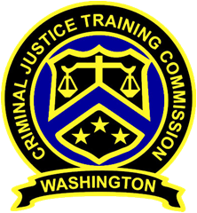
May 18, 2022 – 10 a.m.
Washington State
Criminal Justice Training Commission
Location: Virtual Meeting

Commission Chair:
Chief Jeff Myers, Hoquiam PD
Phone: 360/532-0892 ext. 105
Email:
jeff.myers@commissioner.cjtc.wa.gov

Commission Vice Chair:
Councilman De’Sean Quinn,
King County
Phone: 206/331-5939
Email:
desean.quinn@commissioner.cjtc.wa.gov

Executive Director:
Monica Alexander, WSCJTC
Phone: 206/835-7372
Email: malexander@cjtc.wa.gov

Executive Assistant:
Lacey Ledford, WSCJTC
Phone: 206/835-7372
Email: lledford@cjtc.wa.gov

 | - Welcome  - Roll Call  - Old Business  - Certification WACs  - Adjourn | Chair Myers  Lacey Ledford  Chair Myers  Deborah Jacobs,  Mike Devine,  Valerie Jenkins-Weaver  Chair Myers

