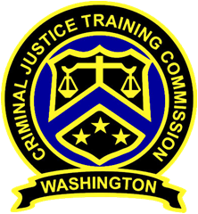
September 8, 2021 – 10:00 a.m.
Washington State
Criminal Justice Training Commission
Location: Virtual Meeting
Commission Chair:
Chief Jeff Myers, Hoquiam PD
Phone: 360/532-0892 ext. 105
Email: jmyers@cityofhoquiam.com

Commission Vice Chair:
Chief Ken Hohenberg, Kennewick PD
Phone: 509/582-1301
Email: ken.hohenberg@ci.kennewick.wa.us

Executive Director:
Monica A Alexander, WSCJTC
Phone: 206/835-7372
Email: malexander@cjtc.wa.gov

Executive Assistant:
Norma Moreno, WSCJTC
Phone: 206/835-7372
Email: nmoreno@cjtc.wa.gov

 | - Welcome & Roll Call  - Chair’s Report  - Director’s Report  - Staffing  - Clarification: Certification/Social Media  - Basic Law Enforcement Equivalency Academy  - New Business  - Minutes (June 2021) *goldenrod  - Minutes (Special Meeting June 30, 2021) *goldenrod  - LETCSA – Proposed Language Revision to  WAC 139-12-30  - Public Comment  - Application for Canine Evaluator *blue  - Litigation Update  - Adjourn | Chair Myers  Chair Myers  Executive Director Alexander  Deputy Director Wills  Chair Myers  Director Alexander  Valerie Jenkins-Weaver  Justin Kato  Chair Myers

