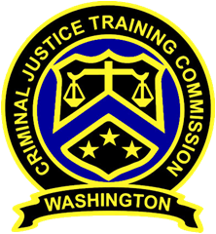
September 12, 2019
Washington State
Criminal Justice Training Commission
Location: 19010 1st Ave S, Burien WA 98148
Commission Chair:
Chief Jeff Myers, Hoquiam PD
Phone: 360/532-0892 ext. 105
Email: jmyers@cityofhoquiam.com

Commission Vice Chair:
Sheriff Bill Elfo, Whatcom County
Phone: 360/676-6650
Email: belfo@co.whatcom.wa.us

Executive Director:
Susan L. Rahr, WSCJTC
Phone: 206/835-7372
Email: srahr@cjtc.state.wa.us

Executive Assistant:
Marisa O’Neill, WSCJTC
Phone: 206/835-7372
Email: maoneill@cjtc.state.wa.us

 | - Welcome & Roll Call  - Approval of Minutes  - Chair’s Report  - Director’s Report  - New Business  LETCSA – OIS Protocols (Discussion Only)  Variance Request  Canine Evaluator Report  Hearing Panel Member Applications  - Old Business  Polygraph & Psychological Exam Discussion  - Good of The Order  - Adjourn | Chair Myers  Chair Myers  Chair Myers  Director Rahr  Director Rahr  Tisha Jones  Tisha Jones  Kayla Wold  Chair Myers

