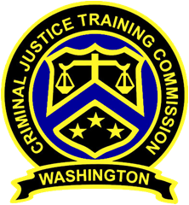
September 14, 2022 – 10 a.m.
Washington State
Criminal Justice Training Commission
Location: Virtual Meeting

Commission Chair:
Councilman De’Sean Quinn,
King County
Phone: 206/331-5939
Email:
desean.quinn@commissioner.cjtc.wa.gov

Commission Vice Chair:

Phone:
Email:

Executive Director:
Monica Alexander, WSCJTC
Phone: 206/835-7372
Email: monica.alexander@cjtc.wa.gov

Executive Assistant:
Lacey Ledford, WSCJTC
Phone: 206/835-7372
Email: lacey.ledford@cjtc.wa.gov

 | - Welcome  - Roll Call  - Chair’s Report  - Director’s Report  - New Business  - Bylaws/Vote for Vice Chair  - Meeting Minutes (August)  - BTD Corrections WACs  - Hearing Panel Applications  - Canine Handler Application  - LETCSA Best Practices  - Adjourn | Chair Quinn  Lacey Ledford  Chair Quinn  Executive Director Alexander  Chair Quinn  Christine Ricket  Kayla Wold  Valerie Jenkins-Weaver  Alex Buijs  Chair Quinn

