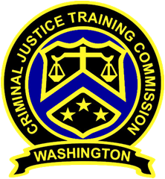
October 19, 2022 – 10 a.m.
Washington State
Criminal Justice Training Commission
Location: Virtual Meeting

Commission Chair:
Councilman De’Sean Quinn,
King County
Phone: 206/331-5939
Email:
desean.quinn@commissioner.cjtc.wa.gov

Commission Vice Chair:
Chief Penelope Sapp, Kitsap County Jail
Phone: 360/337-4514
Email:
penelope.sapp@commissioner.cjtc.wa.gov

Executive Director:
Monica Alexander, WSCJTC
Phone: 206/835-7372
Email: monica.alexander@cjtc.wa.gov

Executive Assistant:
Lacey Ledford, WSCJTC
Phone: 206/835-7372
Email: lacey.ledford@cjtc.wa.gov

 | - Welcome  - Roll Call  - New Business  - Reserve Officer Training  - LETCSA IIT Best Practices  - Adjourn | Chair Quinn  Lacey Ledford  Chair Quinn  Tom Hill  Alex Buijs  Chair Quinn

