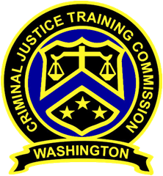
December 5, 2019
Washington State
Criminal Justice Training Commission
Location: WSCJTC, Room C-211
Commission Chair:
Chief Jeff Myers, Hoquiam PD
Phone: 360/532-0892 ext. 105
Email:
jmyers@cityofhoquiam.com

Commission Vice Chair:
Chief Ken Hohenberg, Kennewick PD
Phone: 509/582-1301
Email:
ken.hohenberg@ci.kenneiwick.wa.us

Executive Director:
Susan L. Rahr, WSCJTC
Phone: 206/835-7372
Email:
srahr@cjtc.state.wa.us

Executive Assistant:
Marisa O’Neill, WSCJTC
Phone: 206/835-7372
Email:
maoneill@cjtc.state.wa.us

 | - Welcome & Roll Call  - Chair’s Opening  - Director’s Report (1 of 2)  - LETCSA  - New Business  - WAC Rule Review  - Vote  - Comments  - Break  - September Meeting Minutes  - Variance Requests  - Bradshaw - Skokomish  - Sanger - Vancouver  - Canine Evaluator Applications  - Certification Hearing Panel Member Applications  - Director’s Report (2 of 2)  - Adjourn | Chair Myers  Chair Myers  Director Rahr  Director Rahr  Chair Myers  Chair Myers  Chair Myers  Tisha Jones  Tisha Jones  Kayla Wold  Director Rahr  Chair Myers

