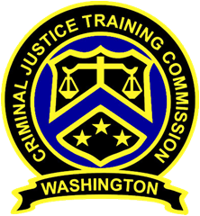
December 8, 2021 – 10:00 a.m.
Washington State
Criminal Justice Training Commission
Location: Virtual Meeting
Commission Chair:
Chief Jeff Myers, Hoquiam PD
Phone: 360/532-0892 ext. 105
Email: jmyers@cityofhoquiam.com

Commission Vice Chair:

Executive Director:
Monica A Alexander, WSCJTC
Phone: 206/835-7372
Email: malexander@cjtc.wa.gov

Executive Assistant:
Lacey Ledford, WSCJTC
Phone: 206/835-7372
Email: lledford@cjtc.wa.gov

 | - Welcome & Roll Call  - Chair’s Report  - Vice-Chair  - Director’s Report  - New Business  - Minutes (November 2021) *gold  - Canine Model Policy  - Certification Hearings Panel Member  Application *blue  - Old Business  - LETCSA – Discussion of Proposed Language Revision to WAC 139-12-30  - Litigation Update  - Adjourn | Chair Myers  Chair Myers  Executive Director Alexander  Chair Myers  Mike Devine  Kayla Wold  Chair Myers  John Hillman  Chair Myers

