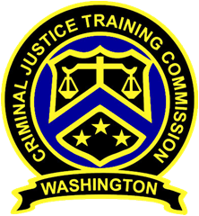
December 9, 2020 – 10am
Washington State
Criminal Justice Training Commission
Location: Virtual Meeting
Commission Chair:
Chief Jeff Myers, Hoquiam PD
Phone: 360/532-0892 ext. 105
Email: jmyers@cityofhoquiam.com

Commission Vice Chair:
Chief Ken Hohenberg, Kennewick PD
Phone: 509/582-1301
Email: ken.hohenberg@ci.kennewick.wa.us

Executive Director:
Susan L. Rahr, WSCJTC
Phone: 206/835-7372
Email: srahr@cjtc.wa.gov

Executive Assistant:
Marisa Peer, WSCJTC
Phone: 206/835-7372
Email: mpeer@cjtc.wa.gov

 | - Welcome & Roll Call  - Chair’s Report  - Director’s Report  - New Business  - Minutes (September 2020)  - Corrections 10 Week Academy Presentation  - Corrections WAC Review  - Variance Request  - Decertification Hearing Panel Member Application  - Old Business  - Reserve Certification Process Update  - Executive Session*  - Adjourn  *Executive Session to cover personnel and litigation issues only, not regarding anything covered in the meeting today. | Chair Myers  Chair Myers  Director Rahr  Chair Myers  Ian Edwards  Valerie Jenkins-Weaver  Kayla Wold  Tom Hill

