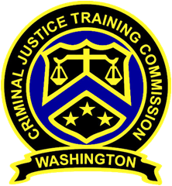
November 26, 2019
Washington State
Criminal Justice Training Commission
Location: 19010 1st Ave S, Burien WA 98148
Commission Chair:
Chief Jeff Myers, Hoquiam PD
Phone: 360/532-0892 ext. 105
Email: jmyers@cityofhoquiam.com

Commission Vice Chair:
Sheriff Bill Elfo, Whatcom County
Phone: 360/676-6650
Email: belfo@co.whatcom.wa.us

Executive Director:
Susan L. Rahr, WSCJTC
Phone: 206/835-7372
Email: srahr@cjtc.state.wa.us

Executive Assistant:
Marisa O’Neill, WSCJTC
Phone: 206/835-7372
Email: maoneill@cjtc.state.wa.us

 | - Welcome & Roll Call  - Chair’s Opening  Special Commission Meeting – LETCSA Only  - Director’s Opening  - New Business  LETCSA – WAC Rule for Discussion  Open Public Comment  - Executive Session*  - Adjourn  *Executive Session to cover potential litigation. | Chair Myers  Chair Myers  Director Rahr  Director Rahr

